Sourav Kumar Kuila

Education

Technical Skills – C, JAVA, HTML, CSS, MongoDB, Spring Boot, Angular.

|  |  |  |  |  |
| --- | --- | --- | --- | --- |
| Course | Institute/College | Board | Score | Year |
| Class X | TPS DAV Public School Baharagora | CBSE | 8.4  CGPA | 2015 |
| Class XII | Vikash Residential School BBSR Khurda, Orissa | CBSE | 77.8% | 2017 |
| B.Tech in Biotechnology with Regenerative Medicine | SRM Institute of Science and Technology-Kattankulathur Campus |  | 8.62  CGPA | 2022 |

Work Experience

3 months of training in Capgemini as Java full stack developer.

**Project**

**.** Hotel management system using angular 13.

The objective of developing this application to manage day to day activities performed by various hotel which maintains the guest, booking, room.it perform the new booking and also used for Cancelling, check in and check out.it also used to get bookings and department reports also able to generated the booking receipts also created the login page for three different user and used form validation and authentication. I have created the frontend by using angular, HTML, CSS, Typescript.

I have created 4 microservice and each of the microservice register into eureka server and running on different port number. all the microservice are connected with   
MongoDB database. I have used swagger API which enable to write app documentation design and connect with spring security.

. Studies on Removal of Microplastic using Microorganisms.

To find out microorganisms that efficiently degrade microplastics and compare various microorganisms depending on the rate of degradation of the microplastics.

. SAHA Institute of Nuclear Physics, Kolkata (June - July 2019)

Aptamer Conjugated with gold nanoparticles validated by UV-Vis spectroscopy.

To Find out the successful conjugation of DENV specific with synthesized AUNP with spectroscopic methods.

Certification

**.** The complete 2021 web development bootcamp.

**Certificate link -** ude.my/UC-98fdd84d-2ed2-46be-9faa-592fcf360c0b

**. Human Molecular Genetics, IIT Kanpur.**

NPTEL Issued on – March 2021

Credential ID NPTEL21BT02S21330010

**. Functional Genomics, IIT Kanpur**

NPTEL Issued on – 2020

Credential ID NPTEL20BT40S41690046

. **Molecular Biology-RNA Processing and Translation, Massachusetts Institute of Technology**

**Volunteer Experience**

. Event coordinator in Aarush

Managed a team of 50 volunteers under my domains.

Aarush is a national level techno management fest of SRM University Kattankulathur Campus.

**Honours and Awards**

. International conference on recent advances in biosciences and bioengineering.

Nano patches for treatment of burn injuries: application and future prospects.

. First prize in quiz competition, National service scheme.

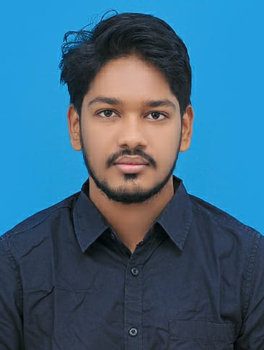

Personal Details

Date of Birth – 01 October 1999

Fathers Name – Tarun Kumar Kuila

Nationality - Indian

Contact

Address – At – Patpur Po/Ps – Baharagora Landmark – Bsnl Exchange Office Road Baharagora, East Singbhum, Jharkhand 832101

Phone Number - 8825113878

Email – kuila.sourav1999@gmail.com

Linked in - www.linkedin.com/in/sourav-kumar-kuila-1aa543213

GitHub - https://github.com/souravkumarkuila

Languages Known

English

Hindi